**Talk Box (Speech Generating Device)**

**User Manual**

Installation:

Link to the project: <https://github.com/ryang-123/EECS2311-Project/>

* Downloading Jar File
* Running Jar file to customize buttons and voice inputs.
* Create customized Talkbox applications.
* Monitoring the use of the application through implemented logging system.

How to get started:

1. The TalkBox window will appear after running the application. This home window is where the user can get access to the available functionalities.

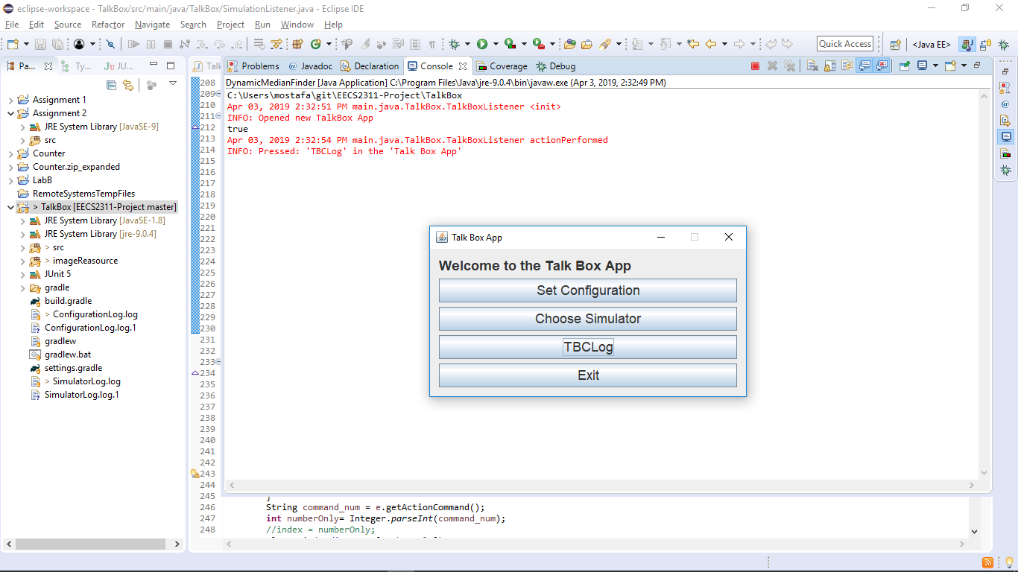

*Set Configuration:*

This is where the user goes through the configuration for all the buttons and the layout of the Talk Box. It is the main interface for the creation of the buttons and uploading the necessary files.

1. After choosing ‘Set Configuration’, it will ask for the required number of buttons (four buttons are chosen for the guide), and it will ask the user to give the profile a name (for simulation purposes):

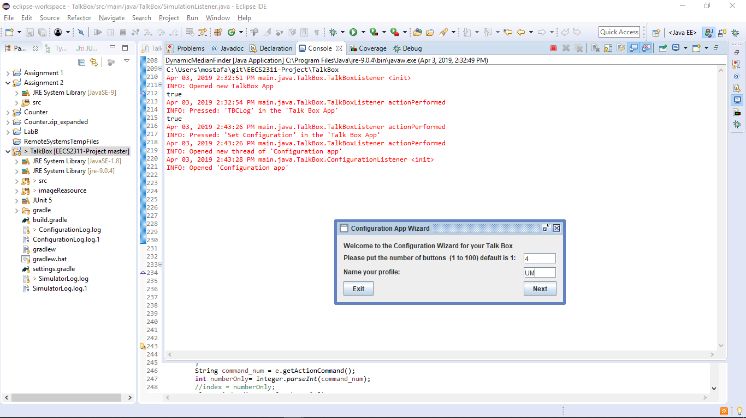

1. Creates the intended number of buttons and then prompts the user to set the specified image and audio file (unique to user needs)

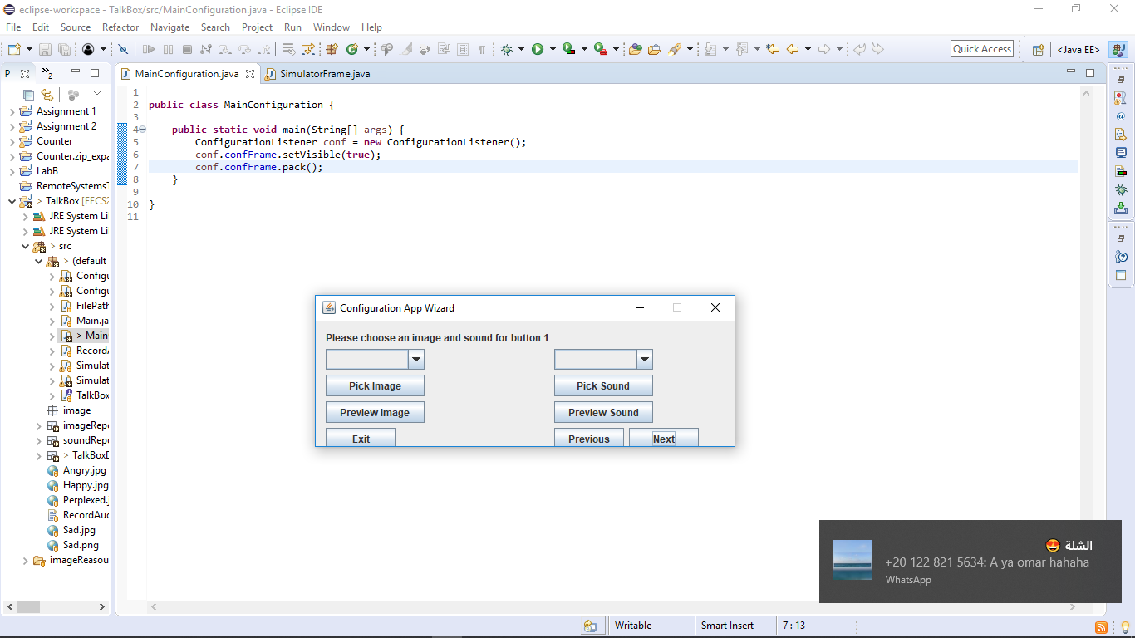

1. This window has two drop down fields. They help the user specify how they want to set the sound or image:
   1. Image:

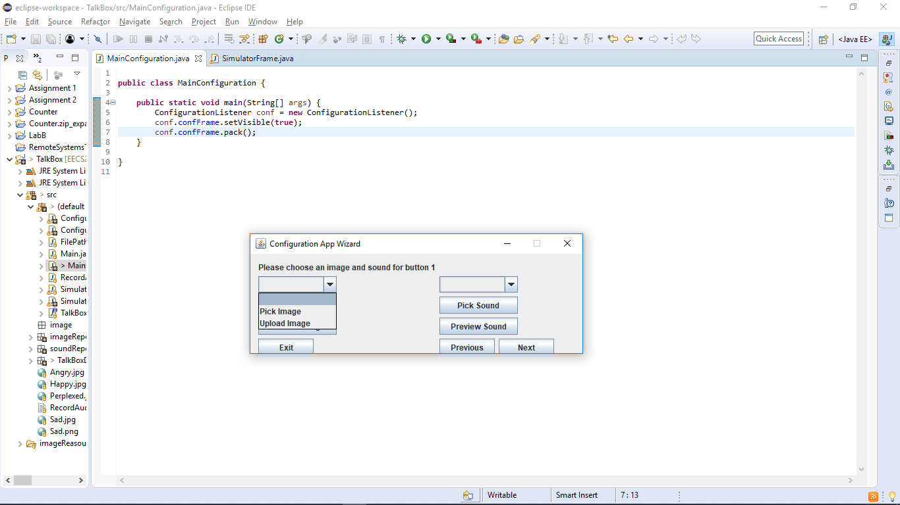

* For the image list the user is prompted with two options: Pick Image and Upload image, the window changes respectively depending on the choice:

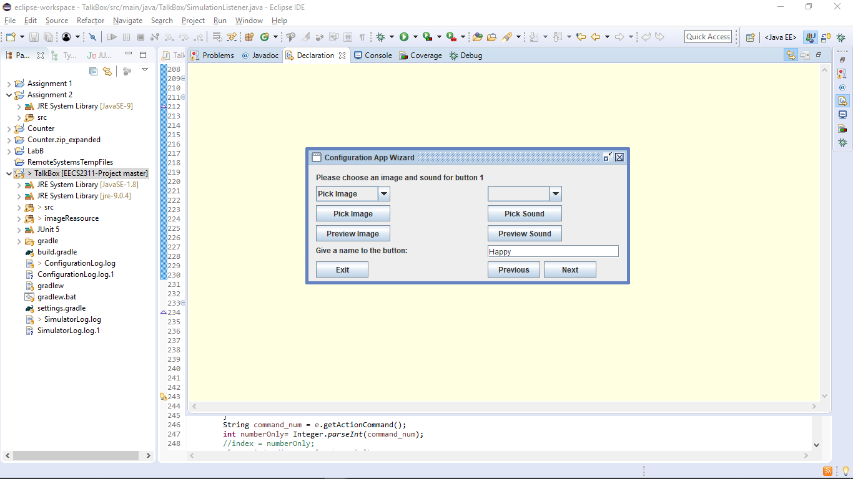 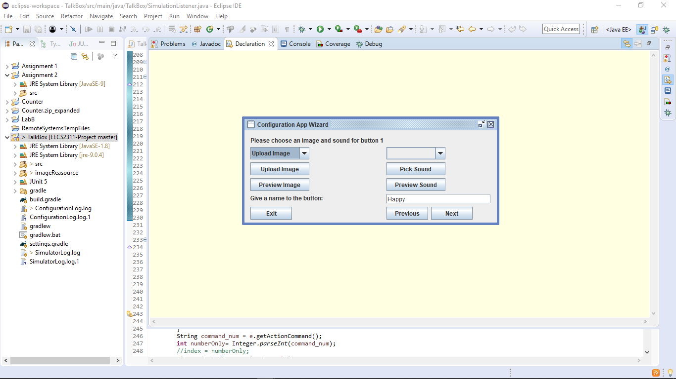

* The respective “Pick Image” and “Upload Image” take them to different windows. The Pick Image button takes them to a folder containing default images and the Upload Image button takes them to their home directory in case they want to use custom files for the configuration. Both are visualized below:

Pick Image: Upload Image:

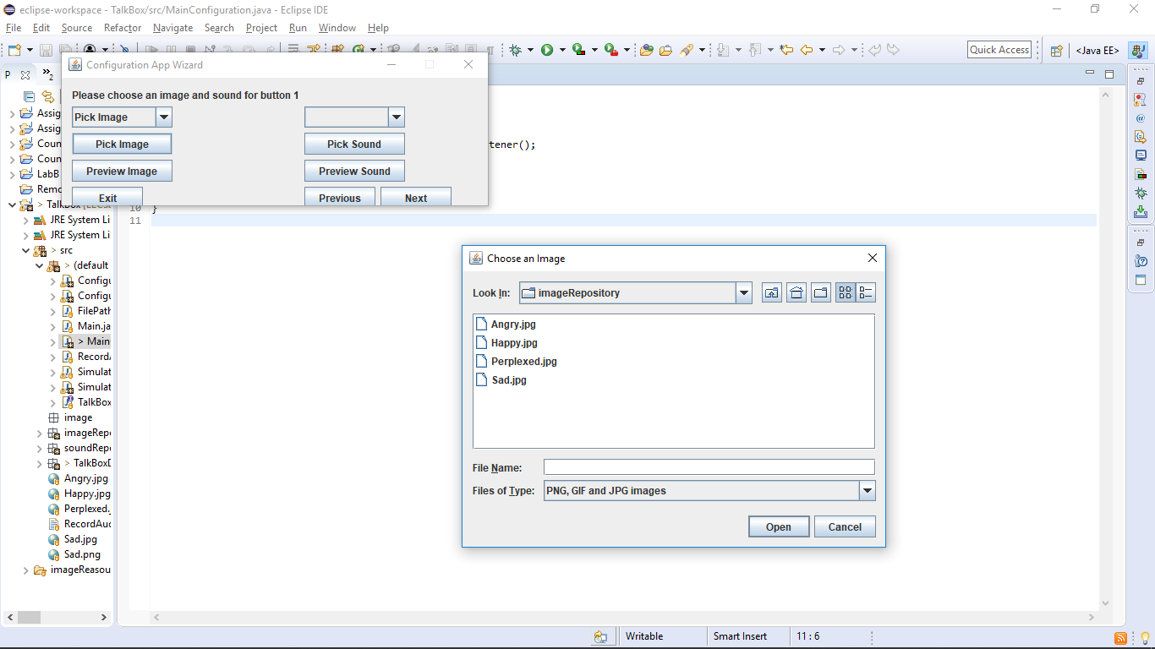 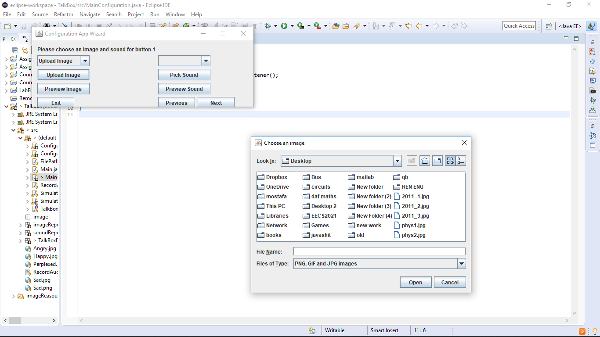

* 1. Sound :

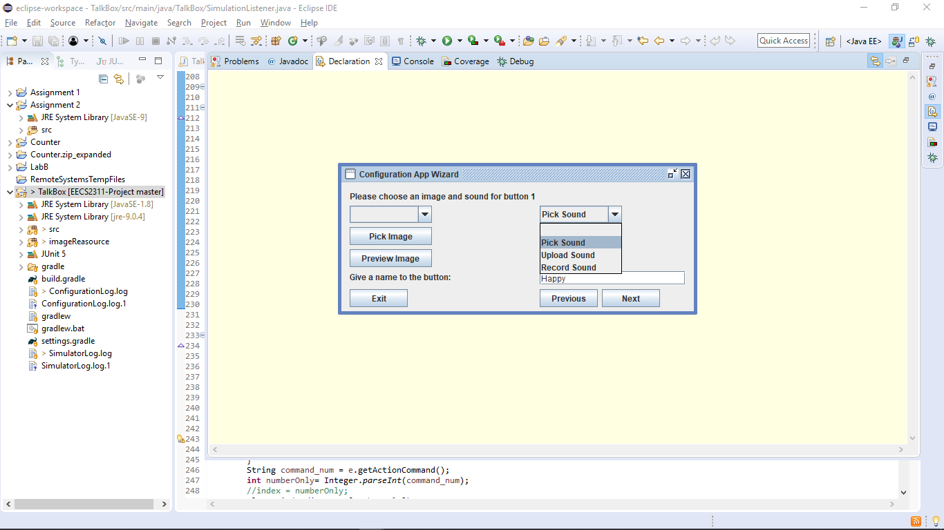

* The user is prompted with 3 options for the sound dropdown menu. The « Pick Sound » and « Upload Sound » are identical to the ones for the Image list. However, the « Record Sound » button permits the user to record their own sound and it changes the window to this :

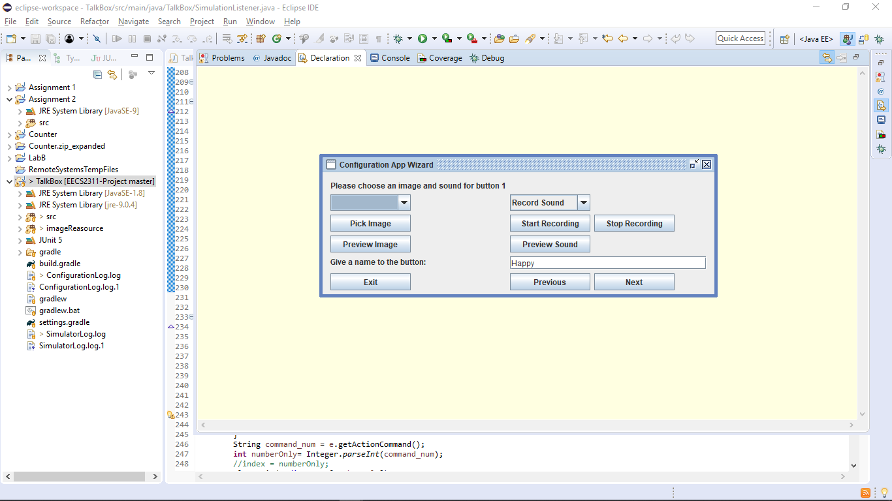

* The « Start Recording » button will prompt the user to speak into a connected microphone, and the « Stop Recording » Button will halt the recording and upload it automatically.

1. The user can proceed by previewing the image/ sound to see how it will look in the simulator after picking the desired image and sound. This is performed by clicking on “Preview Image” and “Preview Sound”

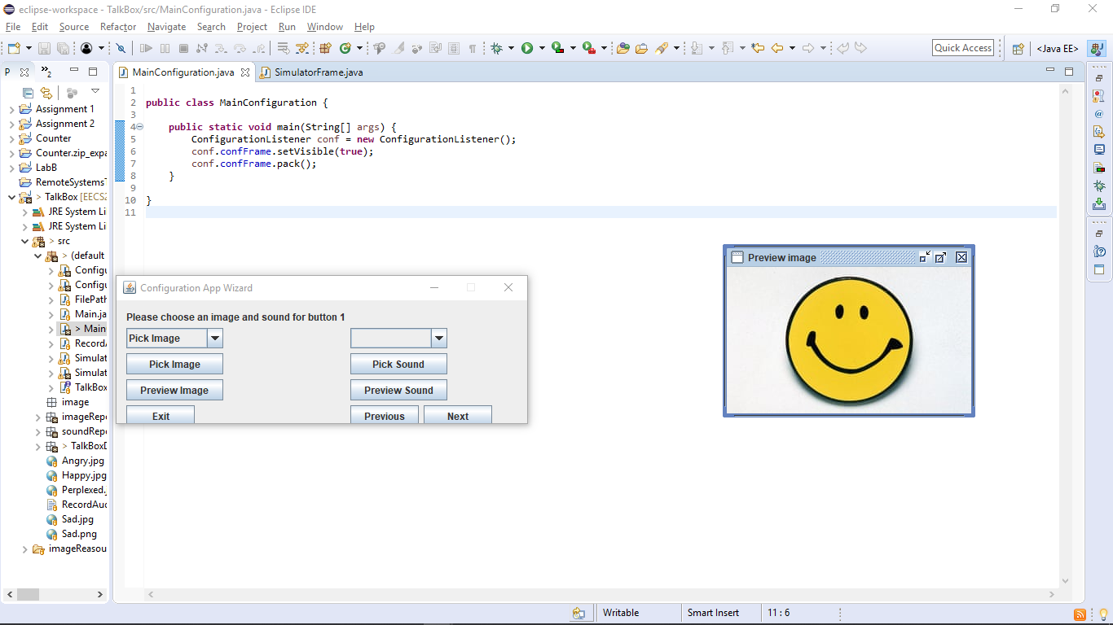

1. The Next button will take the user to another window to configure your next button. You can keep track of which button you are currently changing by reading the first sentence. This will specify the button # for them.
2. The Previous button will take the user to the previous button altered in case they need to change its configuration.
3. The exit button will immediately exit the Configuration App Wizard.
4. After configuring all the buttons and clicking on the final Next button, this window will appear:

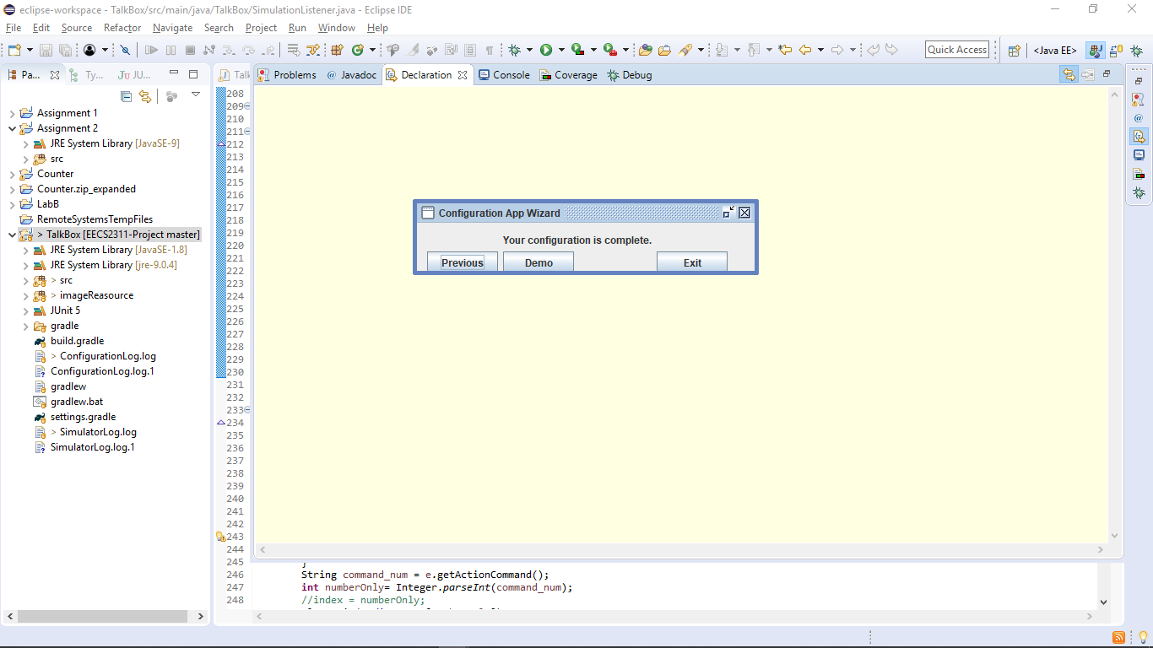

1. Pressing Exit will close the configuration Wizard and save the changes made to the Frame, this is the resulting Frame after having configured 4 buttons. Clicking the buttons will play their respective sound. The Demo button will open a demo of the simulator to see the current state, in case the user wants to make any changes.

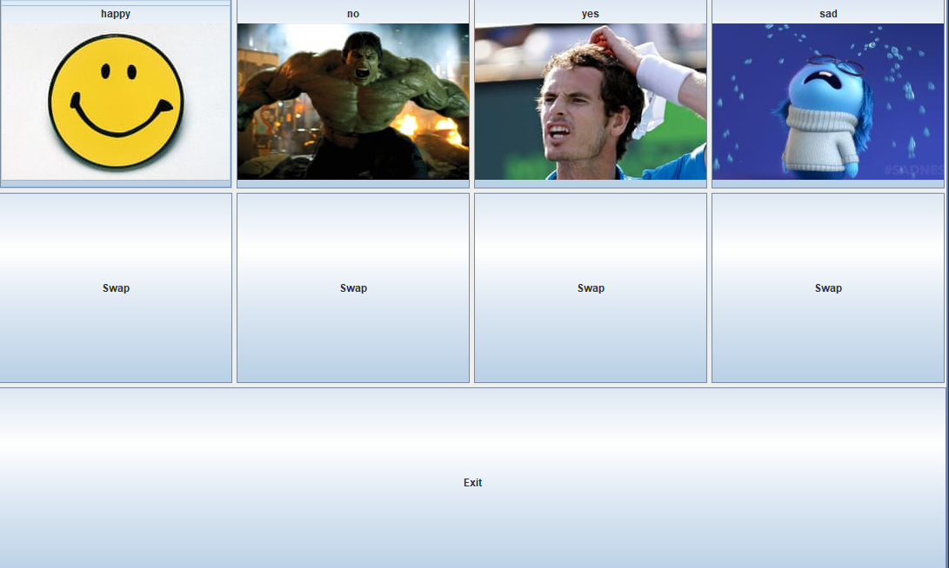

*Choose Simulator:*

1. After choosing ‘Choose Simulator’ the user will be prompted with a window where they can simulate any of their previously created files and see how each one interacts.

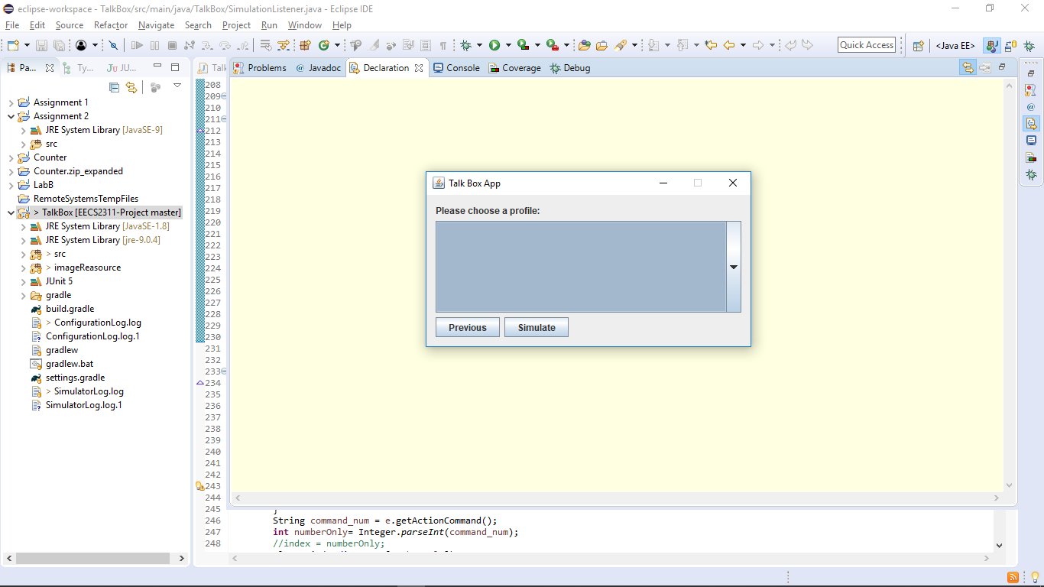

1. The drop-down menu will show the user a list of the created profiles. The name will match the input from the first ‘Configuration App’ window.

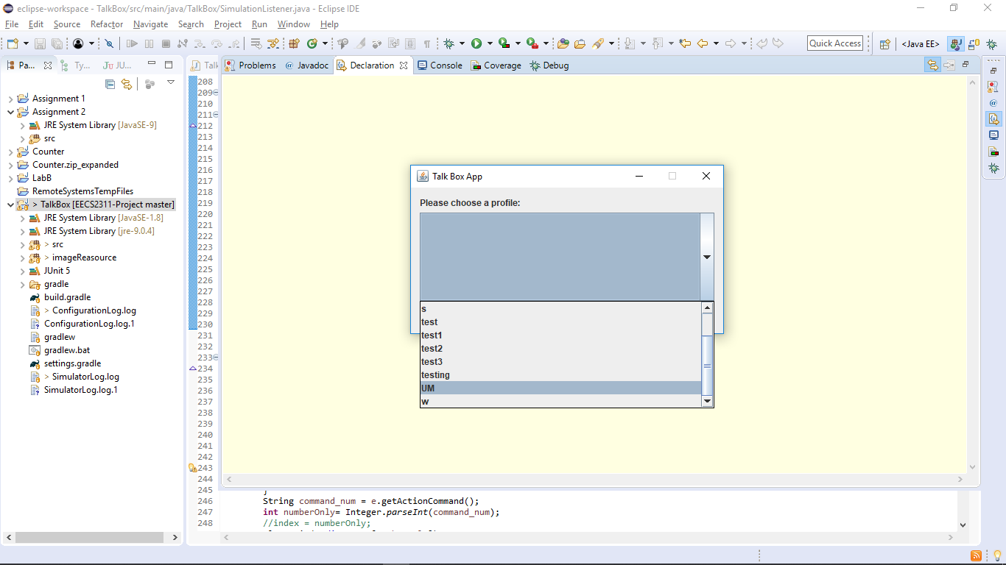

1. For the purpose of the Manual, the configuration chosen was the one created above (UM).

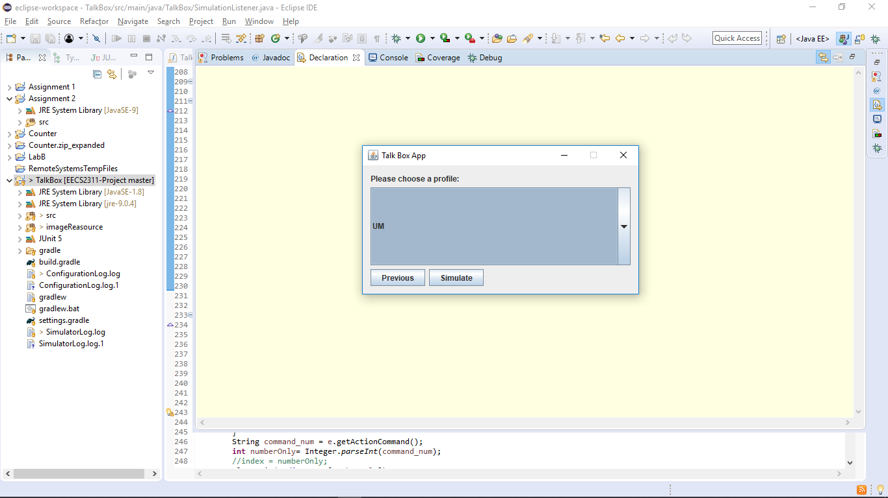

1. The profile that is displayed in the middle is always the profile that is currently being simulated. If the user chooses Simulate it will open the respective simulation.
2. The FrameDemo should function properly and play the audio files when the user clicks the buttons.
3. The user can change between profiles to see a different demo by accessing the drop-down menu.



1. Pressing Previous will take the user to the initial TalkBox App window:

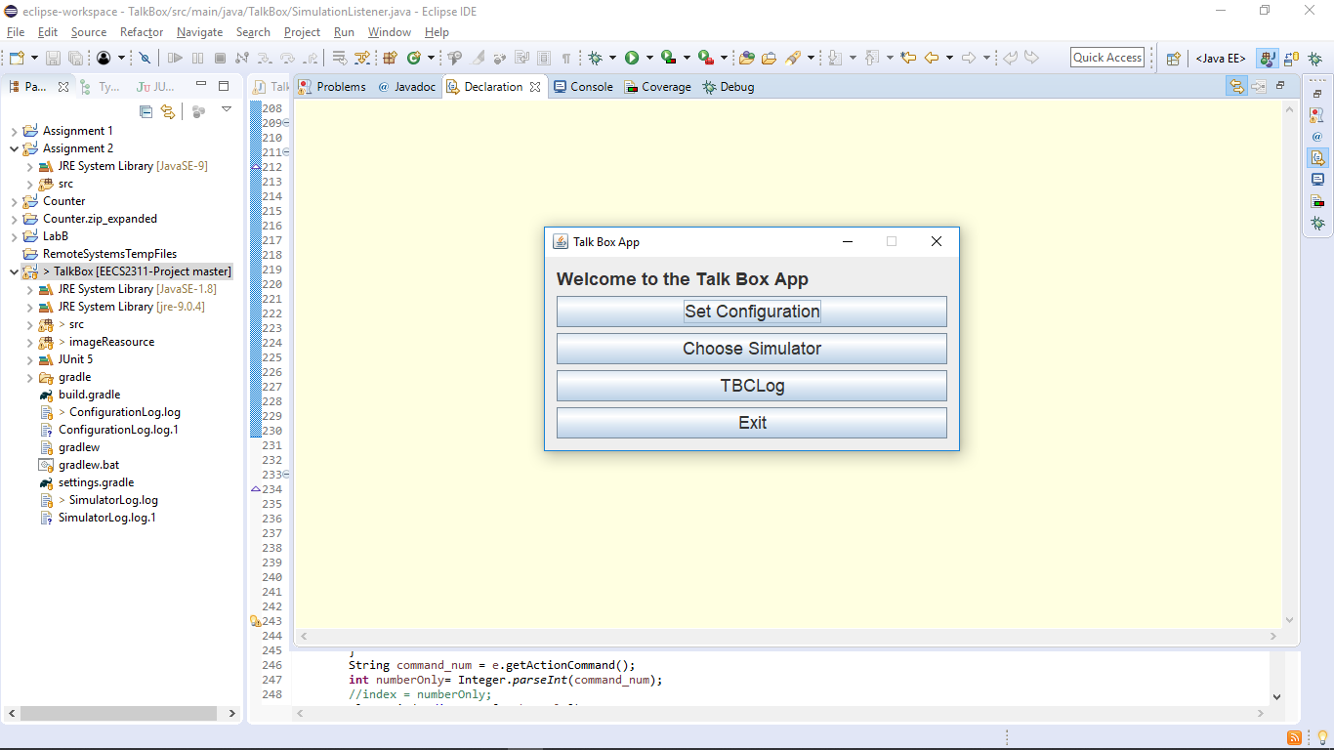

*TBCLog:*

1. Pressing on TBCLog will open two Frames.
   1. The Simulator Logs. This Frame will show certain statistics that are useful for the user and the developers. It tells the user how many times certain events occurred concerning the Simulator.

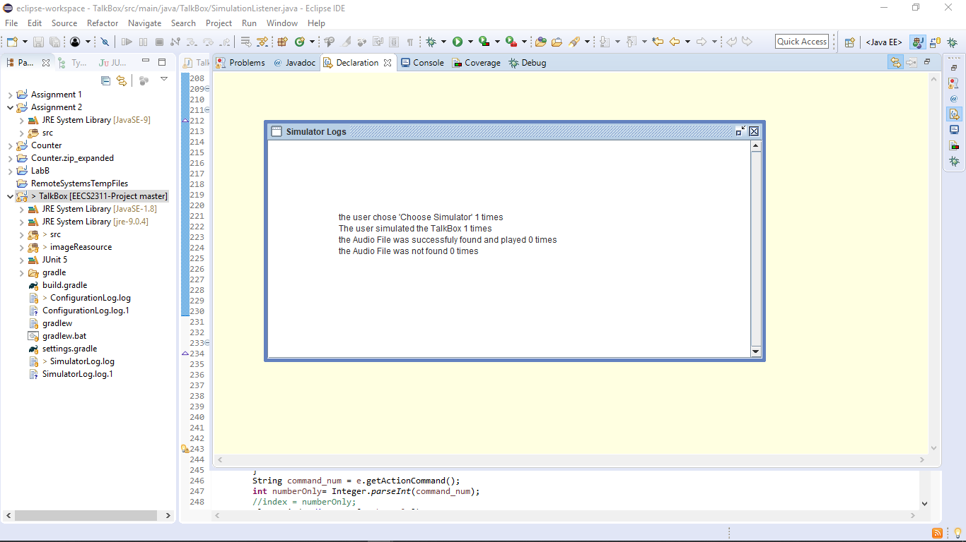

* 1. The Configuration Logs is similar to the aforementioned frame, but with statistics that concern the ‘Configuration App’.
     1. This data is useful for the developers seeing as it keeps track of the general way a user would configure the buttons, which is essential for developing and updating the application with the addition of features.

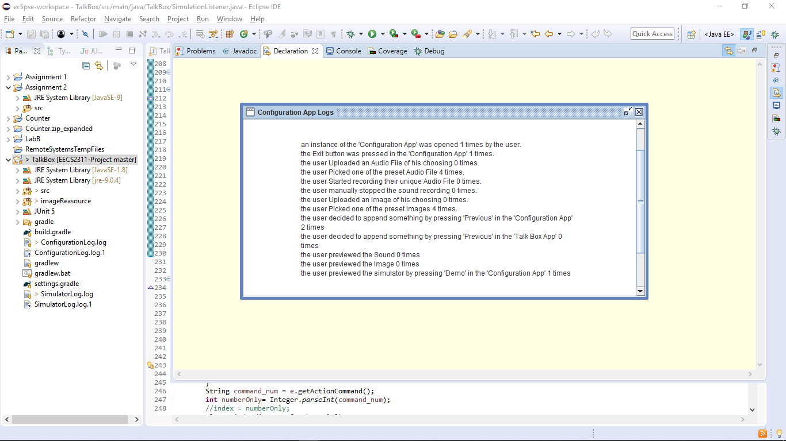

*Exit:*

Pressing on Exit button will terminate the app. However, all the profiles already created will be saved for further use and can be simulated if the app is re-opened.

Special Features:

Swapping Buttons:

Recall the above simulation created. Swapping the button order can be done as follows:

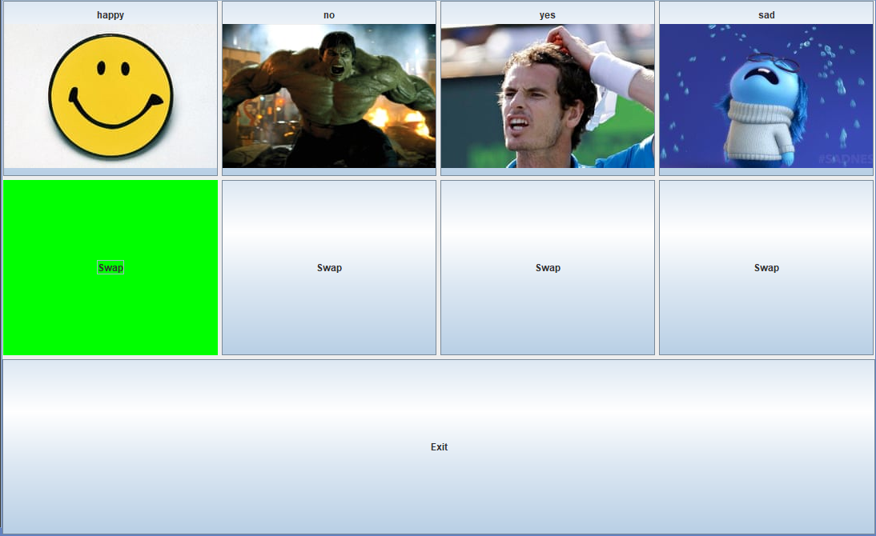

1. Click the swap button situated underneath the button you would like to swap. It will highlight green as shown above.
2. Decide which button to switch and click the swap button underneath it. It will swap with the first selected button. The “happy” button and the “sad” button will switch for this example.
3. The following screenshot depicts the swap. Full functionality maintained for each specific button.

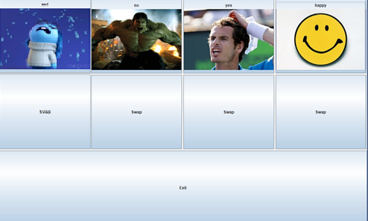

Pagination:

A configuration created with a specific number of buttons causes pagination. Specifically, a next and previous button will populate to convenience the user for switching pages to access all buttons. A visualization of this feature:

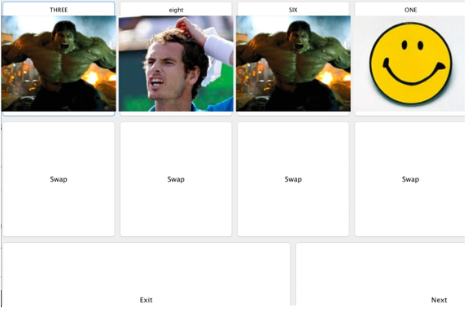

Major Use Cases:

In a more general sense, the main functionalities of the device are accepting audio files and text/images as input, and then outputting audio depending on the user’s needs.

It supports the ability to function in school/workspace, support sociability. Used to voice certain emotions and states. Thus, enhancing communication when sensory, motor, and/or linguistic impairments are involved.

Limitations to the device include user input text to speech functionality, to help in outputting customized responses.